**DSA PRACTICAL FILE**

(CodeChef C language IDE is used for all the programs)

Practical File programs from 1 to 4

Name: Hardik Chhabra

ECAM-1

Roll no.: 2020UEA6504

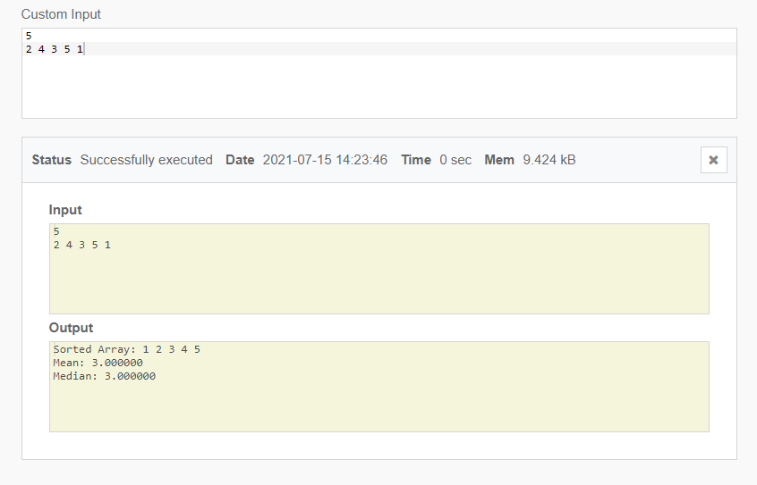**OUTPUT-1**

**Practical-1**

**Q. Write a program to find the mean and median of the numbers stored in an array.**

#include <stdio.h>

int main(void) {

// your code goes here

int n,sum=0;

float mean=0,medn=0;

scanf("%d",&n);

int A[n];

for (int i=0 ; i<n ; i++) {

scanf("%d",&A[i]);

}

for(int k=0 ; k<n ; k++) {

for(int j=0 ; j<n-k-1 ; j++) {

if(A[j+1]<A[j]) {

int temp=A[j];

A[j]=A[j+1];

A[j+1]=temp;

}

}

}

printf("Sorted Array:");

for (int i=0 ; i<n ; i++) {

printf(" %d",A[i]);

}

for (int j=0 ; j<n ; j++) {

sum+=A[j];

}

mean=(float)sum/n;

if(n%2==0) {

n/=2;

medn=(float)(A[n-1]+A[n])/2;

}else {

n=(n/2);

medn=A[n];

}

printf("\nMean: %f\nMedian: %f",mean,medn);

return 0;

}

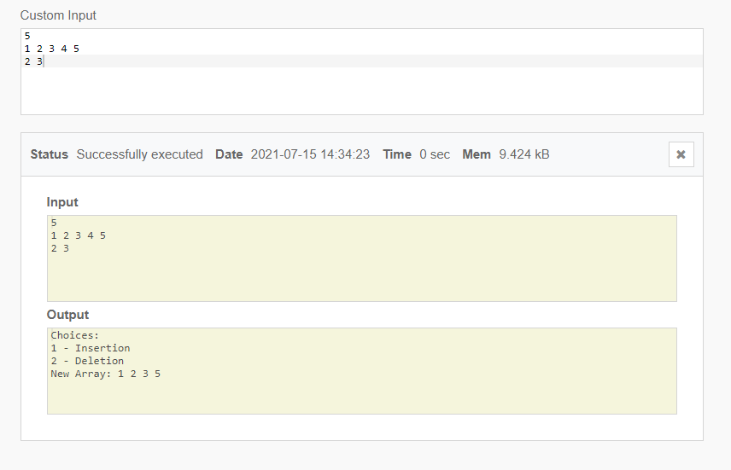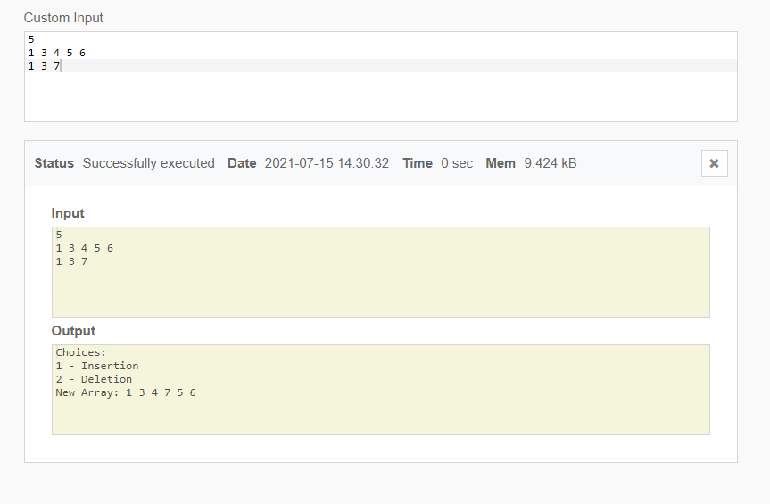**OUTPUT-2**

**Practical-2**

**Q. Write a program to insert one element in an array and delete an element from an array.**

#include <stdio.h>

void insert_elem(int A[],int n) {

int ins_ind;

scanf("%d",&ins_ind);

for(int i=n-1;i>=ins_ind;i--) {

A[i+1]=A[i];

}

scanf("%d",&A[ins_ind]);

n++;

printf("New Array:");

for(int i=0;i<n;i++) {

printf(" %d",A[i]);

}

}

void delete_elem(int A[],int n) {

int del;

scanf("%d",&del);

for(int i=del;i<n;i++) {

A[i]=A[i+1];

}

n--;

printf("New Array:");

for(int i=0;i<n;i++) {

printf(" %d",A[i]);

}

}

int main(void) {

// your code goes here

int m,choice;

scanf("%d",&m);

int A[10];

for(int i=0;i<10;i++) {

if(i<m) {scanf("%d",&A[i]);}

else if(i>=m) {A[i]=0;}

}

// for(int i=0;i<m;i++) {printf("%d",A[i]);}

label:

printf("Choices:\n1 - Insertion\n2 - Deletion\n");

scanf("%d",&choice);

if(choice==1) {

insert_elem(A,m);

}else if(choice==2) {

delete_elem(A,m);

}else {

printf("Enter a suitable choice");

goto label;

}

return 0;

}

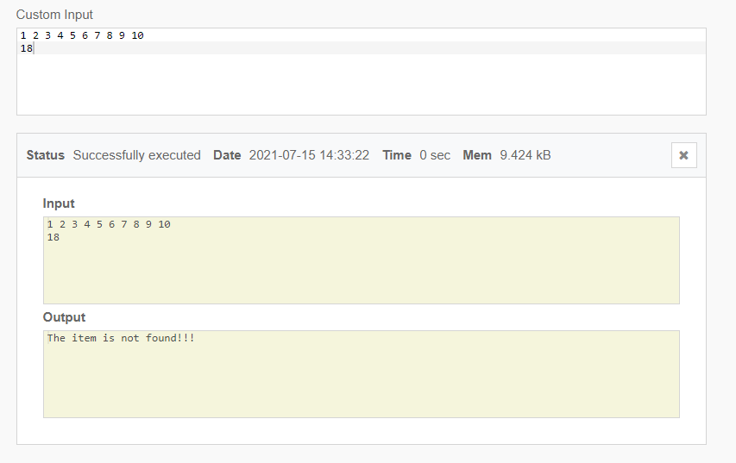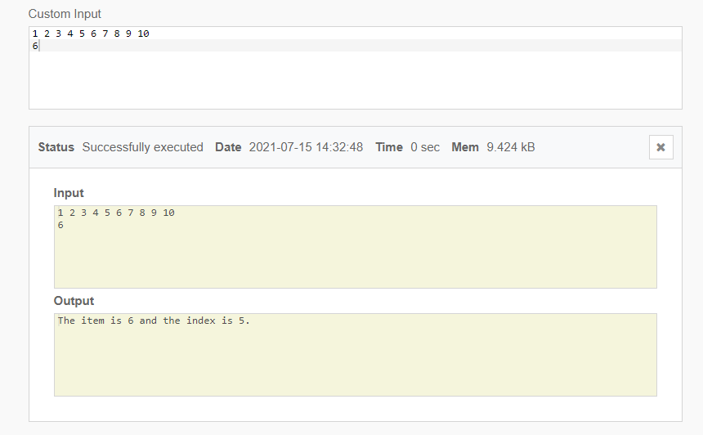**OUTPUT-3**

**Practical-3**

**Q. Write a program to search for a number in an array.**

#include<stdio.h>

int main()

{

int A[10],item;

for(int i=0;i<10;i++) {

scanf("%d", &A[i]);

}

printf("Enter the value to be searched: ");

scanf("%d",&item);

for(int j=0;j<10;j++) {

if(item == A[j]) {

printf("The item is %d and the index is %d.",A[j],j);

return 0;

}

}

printf("The item is not found!!!");

return 0;

}

**OUTPUT-4**

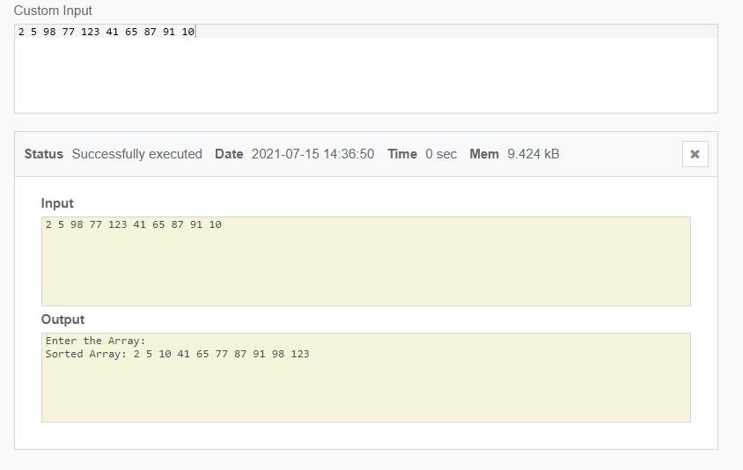

**Practical-4**

**Q. Write a program to sort an array.**

#include <stdio.h>

int main(void) {

// your code goes here

int A[10];

for (int i = 0; i < 10; i++) {

scanf("%d",&A[i]);

}

for (int i = 0; i < 10; i++) {

for (int j = 0; j < 9-i; j++) {

if(A[j]>A[j+1]) {

int temp=A[j];

A[j]=A[j+1];

A[j+1]=temp;

}

}

}

printf("\nSorted Array:");

for (int i = 0; i < 10; i++) {

printf(" %d",A[i]);

}

return 0;

}